Project 1.2
Acadgild - BIG DATA HADOOP & SPARK TRAINING

State-Wise Development Analysis In India
Executive Summary

Project Overview
To develop the System to analyze the log data (In XML format) of government progress of
various development activities
Purpose and Scope of this Specification
The purpose of this project is to capture the data for analyzing the progress of various
activities.
In scope
The following requirement will be addressed in phase 1 of Project:
• Developing system to handle the incoming log feed and store the information in Hadoop
Cluster (Flume)
• Analyze the data and understand the progress
• Store the results in Hbase/RDBMS
Out of scope
We can use this data and visualization and get more insights

Product/Service Description
Assumptions
Log will be generated in XML format and stored in a server
Constraints
Describe any item that will constrain the design options, including
• This system may not be used for searching for now. But it will be used for analysis and
saving the relevant information as of now
• System will be using Hbase as a database
Requirements
• The FLUME job which will format the data and place the data to HDFS
• Pig/MapReduce job for parsing the XML data.
• Create Pig scripts/MapReduce jobs to analyze the data
• Create the Sqoop job to store the data in database
Priority Definitions
The following definitions are intended as a guideline to prioritize requirements.
• Priority 1 – Create FLUME job for fetching log files from spool directory the data
• Priority 2 – MapReduce/pig job to preprocess
Dataset Link:
https://drive.google.com/file/d/0Bxr27gVaXO5sUjd2RWFQS3hQQUE/view?usp=sharing
Dataset file - 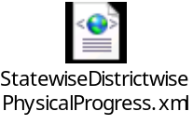

Step 1:
Copy dataset from local file system to HDFS using flume.
Note: use the conf file by attached below



Command:
flume-agent agent –n agent1 –c conf –f <path to filecopy.conf>

Step 2:
Input file is in the XML format use Map reduce or pig to parse the data and get the results for
below problem statements.

Problem statement
1. Find out the districts who achieved 100 percent objective in BPL cards
Export the results to mysql using sqoop
2. Write a Pig UDF to filter the districts which have reached 80% of objectives of BPL cards.
Export the results to MySQL using Sqoop.

(Project Solution starts from next page)...

Local environment setup-
Created directory /home/acadgild/PROJECT-1-IndianStateAnalysis in Acadgild-VM to store all project related files in local machine.
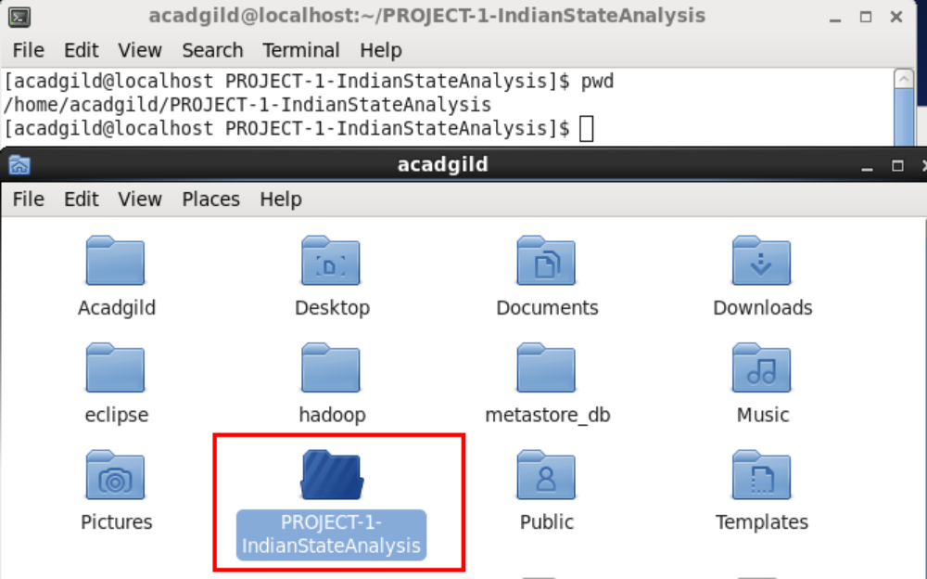

Copied data set and Flume configuration file in directory in Acadgild-VM.
Updated the directory in Flume configuration file (filecopy.conf)
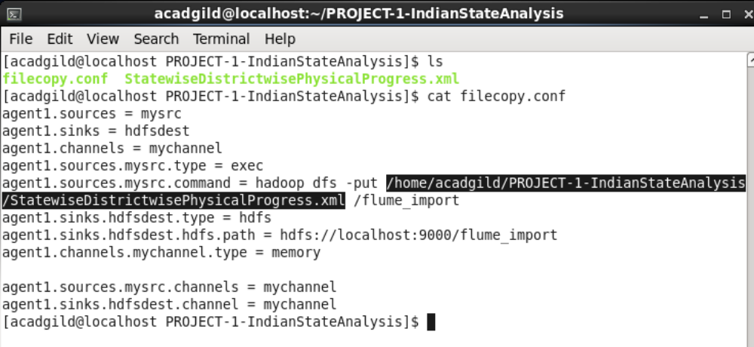

Hadoop environment setup-
Copied Flume configuration file to $FLUME_HOME/conf (/usr/local/flume in acadgild VM)
Command:-
[acadgild@localhost conf]$ pwd
/usr/local/flume/conf
[acadgild@localhost conf]$ cp /home/acadgild/PROJECT-1-IndianStateAnalysis/filecopy.conf .
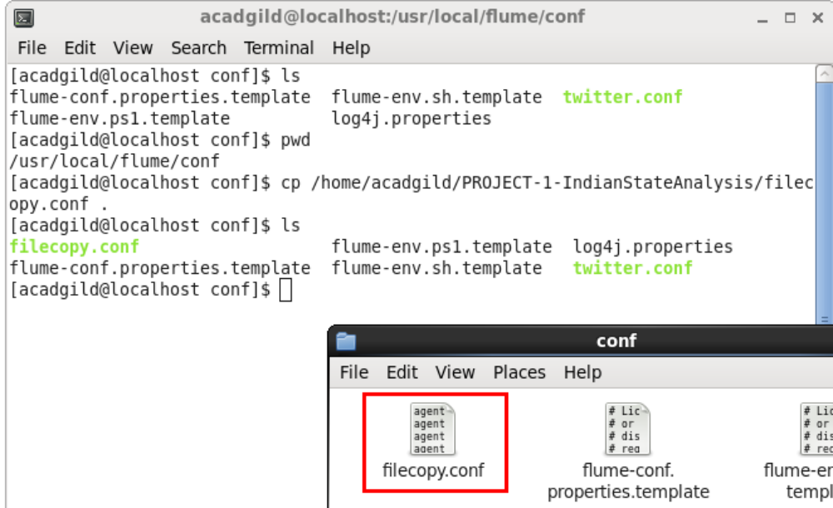

Checking if flume output directory “/flume_import” exists in HDFS or not
Command – hadoop fs –ls /
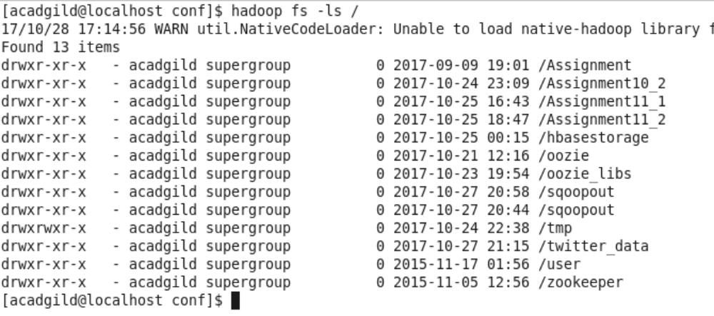
From the screenshot we could see that /flume_import does not exist in HDFS currently. I would be created later when flume job runs.
Now that Local environment and Hadoop environment setup is complete we can proceed with further steps in as mentioned in the project requirement document.

Step 1 - Copying dataset from local file system to HDFS using flume.
Dataset file location - /home/acadgild/PROJECT-1-IndianStateAnalysis/ StatewiseDistrictwisePhysicalProgress.xml
Flume configuration file location - /usr/local/flume/conf/ filecopy.conf
Dataset file -
Flume configuration file -
Output file in HDFS - /flume_import
Command to run flume job –
flume-ng agent --conf ./conf/ -f conf/filecopy.conf -Dflume.root.logger=DEBUG,console -n agent1
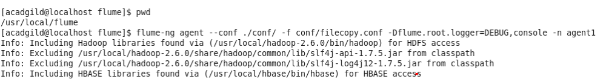
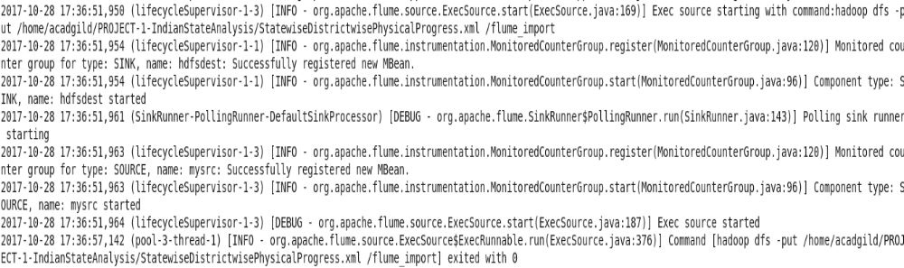

The flume job ran successfully and should have moved the file in HDFS.
Now checking HDFS.
Command – hadoop fs –ls /
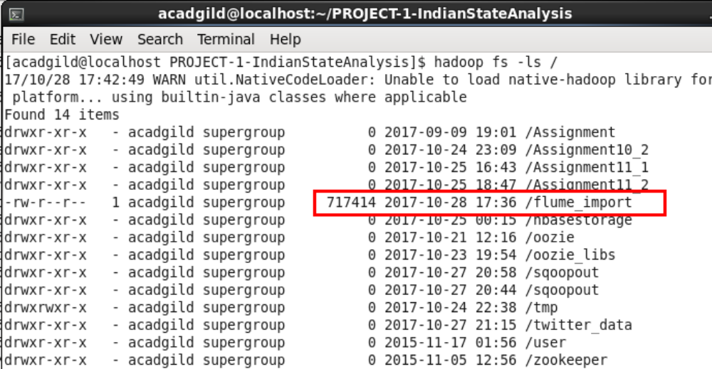
We could see that file “flume_import” hass been created in HDFS root location.
Validated the file by checking its contents and matching file size to that of local environment
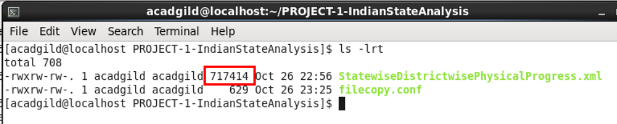
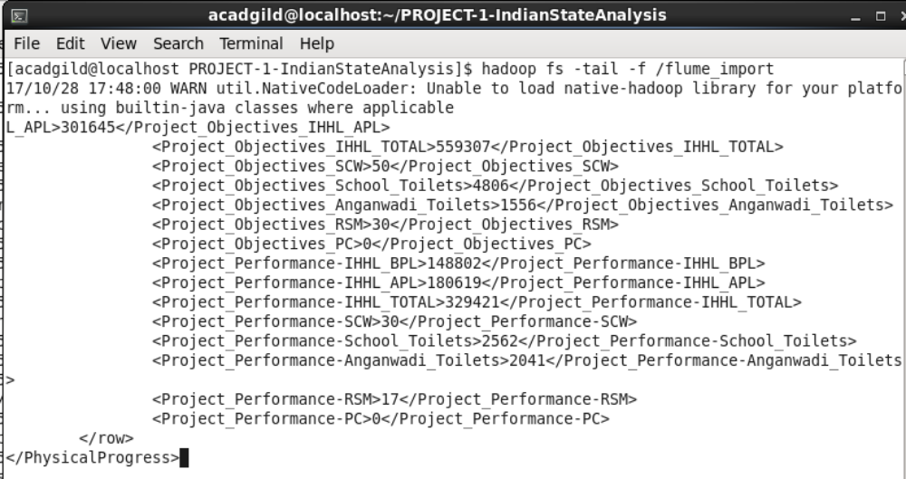
Step 2 - Input file “flume_import” is in the XML format use Map reduce or pig to parse the data and get the results for the problem statements.

would be used for parsing XML data and loading it in PIG.
Copying piggybank.jar to acadgild VM.

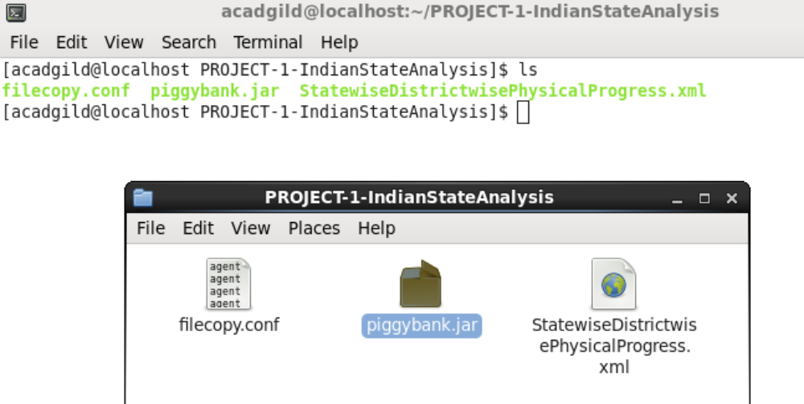

Copying piggybank.jar to HDFS, so that pig running in mapreduce mode would be able to register the jar and use it.
Command - hadoop fs -put piggybank.jar /

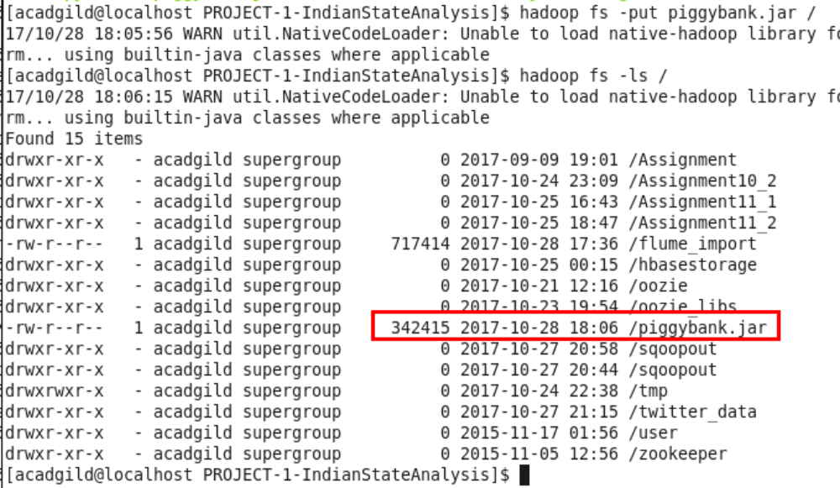

Starting pig in MapReduce mode

Command - pig -x mapreduce

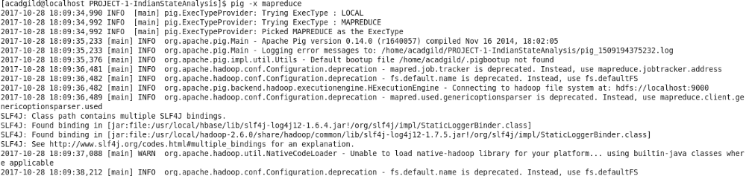

Pig Grunt shell opens up after this. Time to register piggybank.jar file

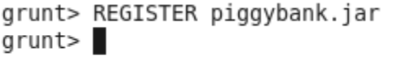
Loading the data file in memory –
XMLData = LOAD '/flume_import' using org.apache.pig.piggybank.storage.XMLLoader('row') as (x:chararray);

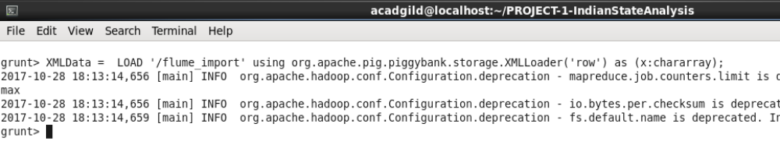

Identifying, parsing and storing rows –

StatesData = foreach XMLData GENERATE FLATTEN(REGEX_EXTRACT_ALL(x,'<row>\\s*<State_Name>(.*)</State_Name>\\s*<District_Name>(.*)</District_Name>\\s*<Project_Objectives_IHHL_BPL>(.*)</Project_Objectives_IHHL_BPL>\\s*<Project_Objectives_IHHL_APL>(.*)</Project_Objectives_IHHL_APL>\\s*<Project_Objectives_IHHL_TOTAL>(.*)</Project_Objectives_IHHL_TOTAL>\\s*<Project_Objectives_SCW>(.*)</Project_Objectives_SCW>\\s*<Project_Objectives_School_Toilets>(.*)</Project_Objectives_School_Toilets>\\s*<Project_Objectives_Anganwadi_Toilets>(.*)</Project_Objectives_Anganwadi_Toilets>\\s*<Project_Objectives_RSM>(.*)</Project_Objectives_RSM>\\s*<Project_Objectives_PC>(.*)</Project_Objectives_PC>\\s*<Project_Performance-IHHL_BPL>(.*)</Project_Performance-IHHL_BPL>\\s*<Project_Performance-IHHL_APL>(.*)</Project_Performance-IHHL_APL>\\s*<Project_Performance-IHHL_TOTAL>(.*)</Project_Performance-IHHL_TOTAL>\\s*<Project_Performance-SCW>(.*)</Project_Performance-SCW>\\s*<Project_Performance-School_Toilets>(.*)</Project_Performance-School_Toilets>\\s*<Project_Performance-Anganwadi_Toilets>(.*)</Project_Performance-Anganwadi_Toilets>\\s*<Project_Performance-RSM>(.*)</Project_Performance-RSM>\\s*<Project_Performance-PC>(.*)</Project_Performance-PC>\\s*</row>'));

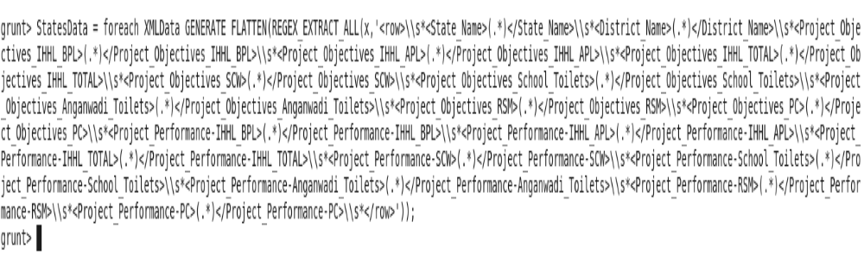
Now all the data in XML file should be loaded in StatesData.
Verifying this by checking contents of StatesData
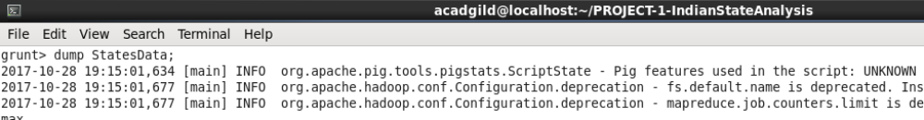
Output-
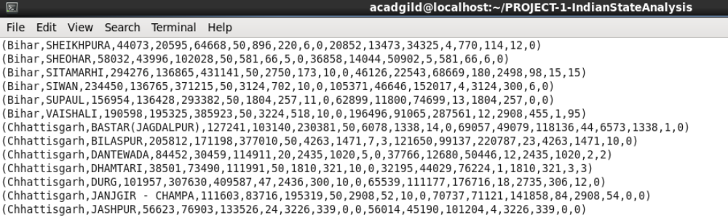

Field | Field Identifier
State_Name | $0
District_Name | $1
Project_Objectives_IHHL_BPL | $2
Project_Objectives_IHHL_APL | $3
Project_Objectives_IHHL_TOTAL | $4
Project_Objectives_SCW | $5
Project_Objectives_School_Toilets | $6
Project_Objectives_Anganwadi_Toilets | $7
Project_Objectives_RSM | $8
Project_Objectives_PC | $9
Project_Performance-IHHL_BPL | $10
Project_Performance-IHHL_APL | $11
Project_Performance-IHHL_TOTAL | $12
Project_Performance-SCW | $13
Project_Performance-School_Toilets | $14
Project_Performance-Anganwadi_Toilets | $15
Project_Performance-RSM | $16
Project_Performance-PC | $17

Since all the data in dataset has been loaded in PIG, we can proceed with solution of project’s Problem Statements.

Problem statements

Problem 1 - Find out the districts who achieved 100 percent objective in BPL cards
Export the results to MySQL using Sqoop

Solution:-

The solution would be to return district names and their corresponding state names where Project_Performance-IHHL_BPL = Project_Objectives_IHHL_BPL

Hence to get this information we only need four fields from the dataset i.e. State_Name, District_Name, Project_Objectives_IHHL_BPL, Project_Performance-IHHL_BPL

Grunt> Problem1Data = foreach StatesData generate (chararray)$0 as State_Name, (chararray)$1 as District_Name, (int)$2 as Project_Objectives_IHHL_BPL,(int)$10 as Project_Performance-IHHL_BPL;

Grunt> dump Problem1Data;

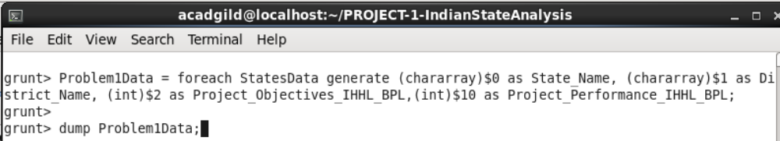

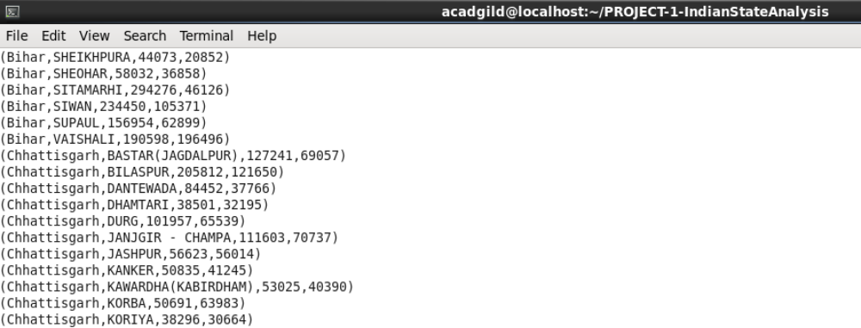

Selecting rows from Problem1Data for districts which have achieved 100 percent objective in BPL cards i.e. Project_Objectives_IHHL_BPL ==Project_Performance_IHHL_BPL

Grunt> Problem1DataFiltered = filter Problem1Data by Project_Objectives_IHHL_BPL ==Project_Performance_IHHL_BPL;

Grunt> dump Problem1DataFiltered;

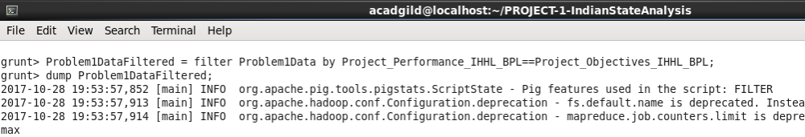

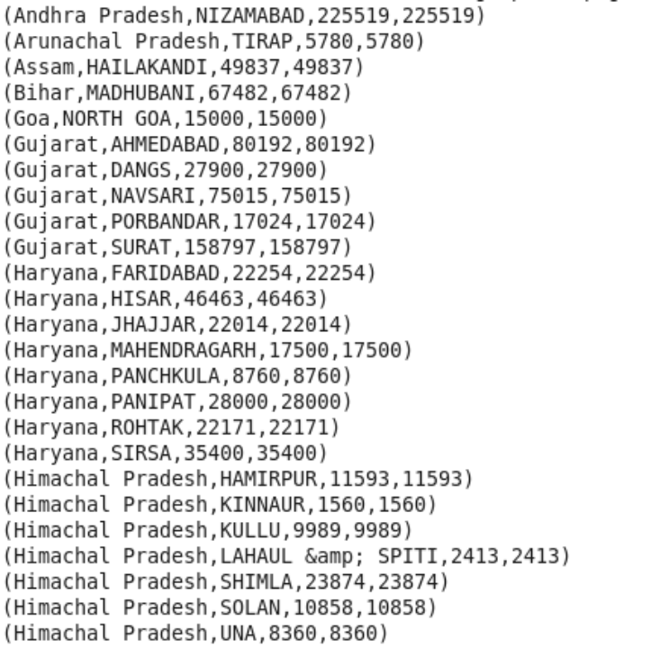

Selecting District and State name from Problem1DataFiltered

Grunt> DistrictNames = foreach Problem1DataFiltered generate District_Name, State_Name;
Grunt> dump DistrictNames;

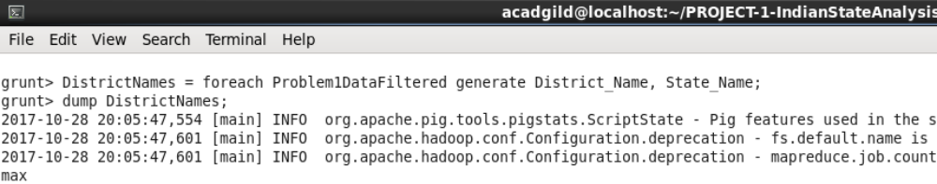
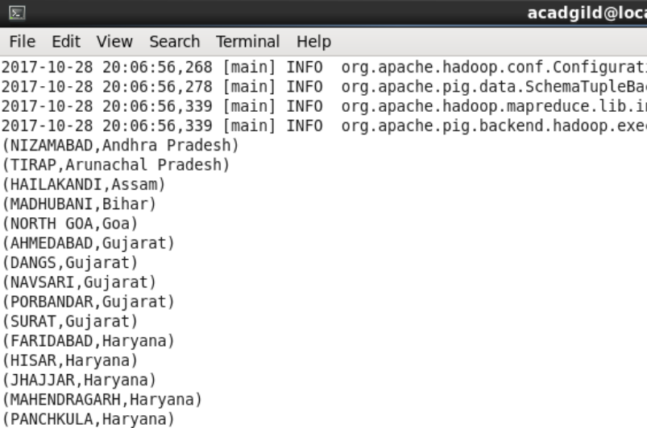

Problem 2 - Write a Pig UDF to filter the districts which have reached 80% of objectives of BPL cards.
Export the results to MySQL using Sqoop.

Solution:-

